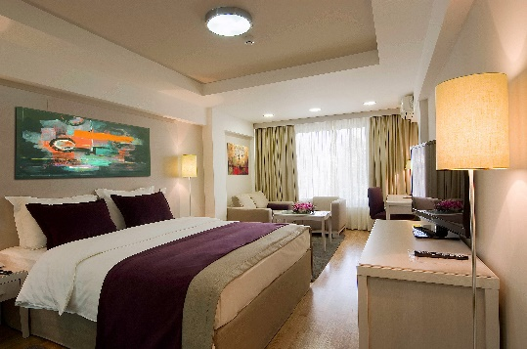

Accommodation Booking Form
Hotel M ****

FEBS3 + MEETING
24th – 27th September 2025 - Belgrade, Hotel M

A. PARTICIPANT’S DETAILS - please fill in capital letters
Title: | ☐Mr. | ☐ Mrs. | ☐ Other

*Surname: |  | *First name:
*Institution: |  | *Department:
*Postal Address: |  | *Postal code:
*City / State: |  | *Country:
*Telephone: |  | *Fax:
*E-Mail:

- ACCOMMODATION & FOOD RESTRICTION:
Room type | Single Use | Double Use
Premier room | € 145 ☐ | € 165 ☐
Standard room | € 100 ☐ | € 115 ☐

Please complite the information requested:

Date/time of arrival: | Date/time of departure: | Nights: | No of Single Rooms:

Rate are in Eur on bed and breakfast bases. Tourist tax is excluded.
Tourist tax is 1.5€ per person/day
Further information and hotel description can be found on http: http://www.hotel-m.com/

C. PAYMENT:
☐ By credit card | ☐ Via Bank Transfer
☐ VISA Card | ☐ Master Card |  | ☐ American Express
_/_/_/_/_/_/_/_/_/_/_/_/_/_/_/_/ |  |  | Expiry date: _____/_____
CVC ( card validation code): _/_/_/ |  |  | Name of the card holder: ________________________
( reverse side of the card, in signature field, last 3 digits)

*Note that signing the payment form is mandatory!
I hereby authorize MLADOST TURIST d.o.o to debit my credit card account with the total amount due and any subsequent changes (cancellation, and no-show charges) to the items booked.

*Card holder signature: _________________________

X Via Bank Transfer to the following account:
Payment instructions:
1 Internediary reibursement institution
BKAUATWW
2 Account with the company TP Mladost-turist d.o.o
BACXRSBG – swift code
UniCredit bank, Rajiceva 27-29, 11000 Belgrade, Serbia
3. Beneficiary costumer:
RS35170000030095232042 – IBAN CODE
Company: TP Mladost-turist d.o.o
Street: Bulevar oslobodjenja 56a, 11000 Belgrade, Serbia
Please, contact us if you need a Proforma invoice. Payment of services should be made in EUR.

Bank charges are the responsability of the participants and should be paid at source in additional to the accommodation fees.
Please, make shure the name of the congress /FEBS3/ and the participant are stated on the bank transfer.

D. Cancelation policy for accommodation:
If you cancel your accommodation 48h prior arrival we do not charge any fee. After that we will charge 1 night (no show)
All changes /cancelations has to be sent in writing by email to Hotel M

Return completed Accommodation Booking Form with required payment to HOTEL M****:

Bulevar oslobodjenja 56a, 11000 Belgrade, Serbia
Phone / Fax: +381 11 3090 643
E-mail: info@hotel-m.com

